

The KBV Kathina Committee

cordially invites you to …

# Kathina 2015

Sunday, November 15th

Karuna Buddhist Vihara

497 Sierra Vista Ave #4, Mountain View, CA 94043

Arrive 10:00 am~ Meal offering (vegetarian) 10:45 am

Robe offering ceremony 1:00 pm

Followed by a Dhamma Talk

robe

At the end of the three-month Rains Retreat, the lay community gathers to offer the monastic sangha robe cloth and supplies that will be useful for the coming year. It is both a significant and joyful occasion acknowledging the relationship of friendship and mutual support between the lay people and the monastics.

This is the very first kathina to be offered at Karuna Buddhist Vihara and we are delighted to have six bhikkhunis from three different monasteries join us for the celebration.

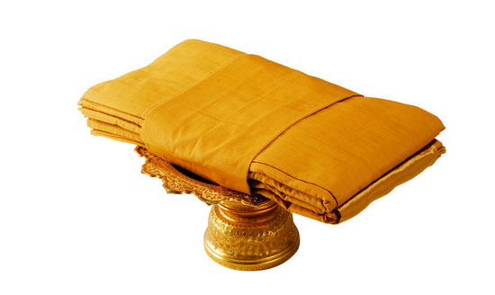

For anyone who would like to participate in the offering, there is a list of useful items at [www.karunabv.org/dana-wish-list.html](http://www.karunabv.org/dana-wish-list.html). Financial contributions can be made out to ‘Karuna Buddhist Vihara.’ To donate using PayPal or other options, please [see our website](http://www.karunabv.org/support.html).

Your donations to KBV are tax deductible.

All your support is appreciated. We hope to see you on November 15th at the Kathina.

Yours in the Dhamma,

The KBV Kathina Committee