Receiving the Heavenly Messengers
Homework Week 3: Preparing for death
- What makes your life worth living? If I lost this, my life would not be worth living.
- Reflect and write on what you would do if you knew you were going to die one month from today.
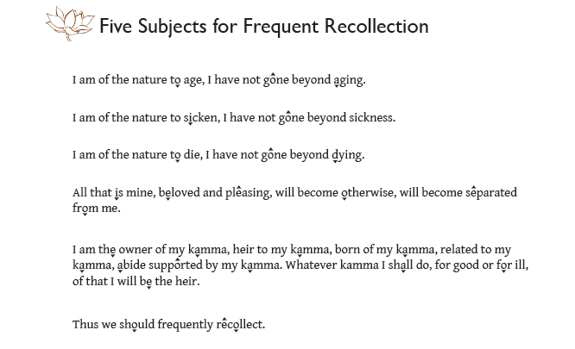
- Continue chanting the “Five Subjects for Frequent Recollection” daily
- Meditation
  - See “Death Contemplations” posted at www.karunabv.org/homework-and-resources.html for meditations on “Contemplating Your Own Death” and the charnel ground meditations from the Satipatthana Sutta: Foundations of Mindfulness in Majjhima Nikaya #10
- Readings: The Heavenly Messengers Medical Guide to Illness, The Heavenly Messengers Spiritual Guide to Illness, ACP Conversation, Living with Death PAMF Newsletter, Being Dead Isn’t a Problem
- Read FIVE WISHES (handout) and fill out as much as you can. Choosing your surrogate is the most important part. They have to be able to represent YOUR wishes faithfully.
- Bring images of death, dying and spiritual development next week for the shrine

