Check-In: **8:15 a.m**.

Walk Starts: **9 a.m.**

Start Location:

**1041 Morse St., SJ**

**Ven. Bhikkhu Bodhi** will lead this 4.6 mile walk

**Lunch Provided: at**

**San Jose Rose Garden**



**Venerable Bhikkhu Bodhi**

**Community Gardens**

**Education for Women and Girls**



Sunday

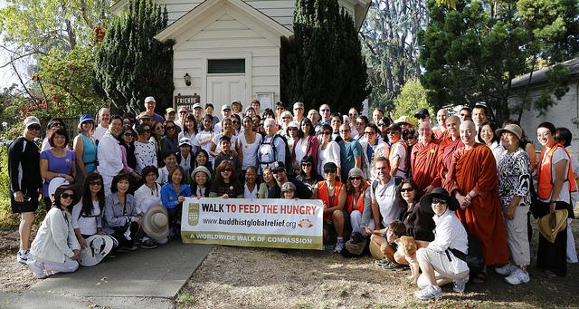

**Sustainable Farming**

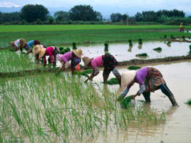

**Oct. 19, 2014**

**Give life and health. Strike at the roots of hunger.**

**And, have a great time doing it.**

**The Walk will also benefit** [**Recovery Café San José**](http://recoverycafesj.org/)

**To register or donate**: [www.firstgiving.com/BuddhistGlobalRelief](http://www.firstgiving.com/BuddhistGlobalRelief)

For more information: call (650) 556-6427

**Direct Food Aid**

San Jose

