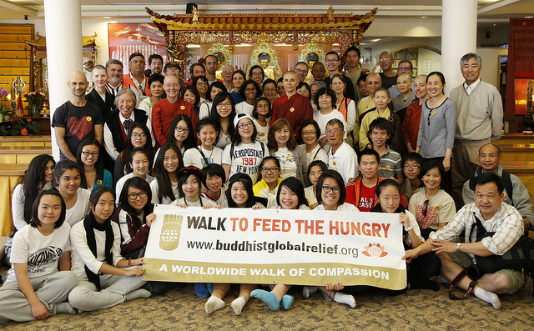

**Venerable Bhikkhu Bodhi**

Check-In: **12 noon**

Walk Start: **12:45 p.m.**

Start Location:

**Norras Temple  
109 Waverly Place**

**San Francisco**

Visit: Buddhist Church of SF

Vietnamese Buddhist Assoc

and more …

**3.5 mile walk**

End: Mindfulness Care Center



Saturday

**Community Gardens**

**Education for Women and Girls**



**Sustainable Farming**

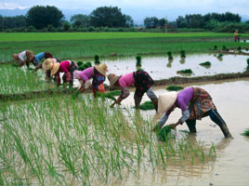

**Oct. 4, 2014**

**Give life and health. Strike at the roots of hunger.**

**And, have a great time doing it.**

**The Walk will also benefit SF** [**Project Open Hand**](http://www.openhand.org/)

**To register or donate**: [www.firstgiving.com/BuddhistGlobalRelief](http://www.firstgiving.com/BuddhistGlobalRelief)

For more information: call (650) 556-6427

**Direct Food Aid**

