**Venerable Bhikkhu Bodhi**

**Education for Women and Girls**

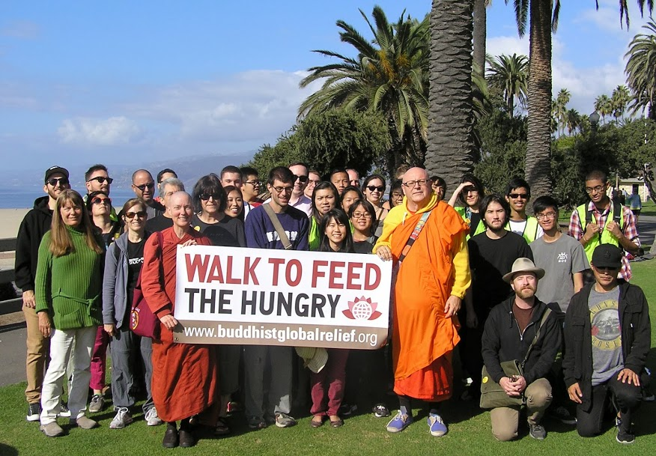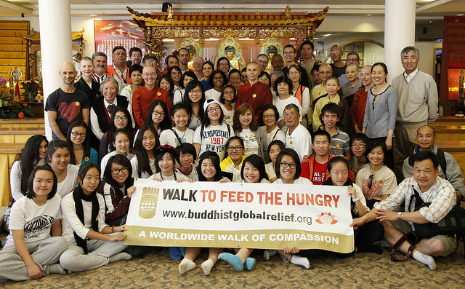

Check-In: **9 a.m.**

Walk Start: **10:00 a.m.**

Start Location:

**Against the Stream**

**Santa Monica Center**

**1001a Colorado Ave**

**Santa Monica, CA 90401**

**Ven. Bhikkhu Bodhi** will lead this 3 mile walk

**Potluck lunch at**

**Against the Stream**



Sunday

**Community Gardens**



**Sustainable Farming**

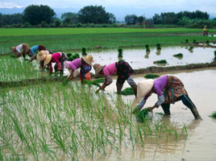

**Oct. 26, 2014**

**Give life and health. Strike at the roots of hunger.**

**And, have a great time doing it.**

**The Walk will also benefit the** [**Westside Foodbank**](http://www.westsidefoodbankca.org/)

**To register or donate**: [www.firstgiving.com/BuddhistGlobalRelief](http://www.firstgiving.com/BuddhistGlobalRelief)

For more information: call **(310) 963-0199**

**Direct Food Aid**

