Being Mortal:
Medicine and what matters in the end
A screening of the film based on the book by
Dr. Atul Gawande

Friday, September 30, 2016
7:00 pm - 8:30 pm
At Insight Meditation Center, Redwood City

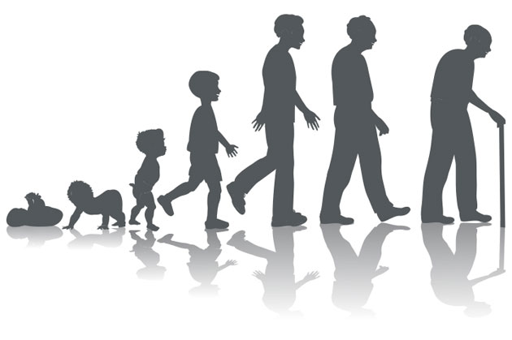
Being Mortal is The PBS video of Atul Gawandi's book by the same name. It shows the dilemma that we all face, patients and caregivers, when confronted with the end-of-life and the kind of care we want. This thought-provoking video helps introduce the kind of conversations we all need to have to ensure that we make the decisions, rather than someone else or a somewhat impersonal medical system. Please join us to watch the video and discuss what this means personally to each of us. The discussion will be led by William M. Buchholz, MD.

Being Mortal:
Medicine and what matters in the end
A screening of the film based on the book by
Dr. Atul Gawande

Friday, September 30, 2016
7:00 pm - 8:30 pm
At Insight Meditation Center, Redwood City

Being Mortal is The PBS video of Atul Gawandi's book by the same name. It shows the dilemma that we all face, patients and caregivers, when confronted with the end-of-life and the kind of care we want. This thought-provoking video helps introduce the kind of conversations we all need to have to ensure that we make the decisions, rather than someone else or a somewhat impersonal medical system. Please join us to watch the video and discuss what this means personally to each of us. The discussion will be led by William M. Buchholz, MD.

