Receiving the Heavenly Messengers
Homework week 4: Preparing for awakening
- What does faith mean to you?
- Reflect (and write) on your experience of awakening, of liberation from suffering.
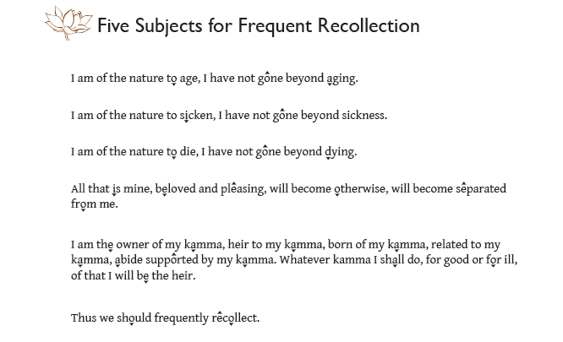
- Continue chanting the “Five Subjects for Frequent Recollection” daily.
- Meditation: the Buddha’s instructions for meditation when approaching death – Beyond Coping pp. 109-111. Listen to the guided meditation online.
- Readings: AN 9-5.doc, Upanisa Sutta, Beyond Coping Advice on Death and Separation pp. 105-122, HM medical guide to dying
- Bring images of serenity, awakening or faith next week for the shrine

