Receiving the Heavenly Messengers
Homework: Follow-up on Aging - Preparing for Illness
- When did you realize that illness and injury can happen to you?
- Choose one common disease each day: cancer, stroke, pneumonia, heart attack, dementia/Alzheimer’s and reflect and write on how you would live with this if it happened to you and bring your reflections next week.
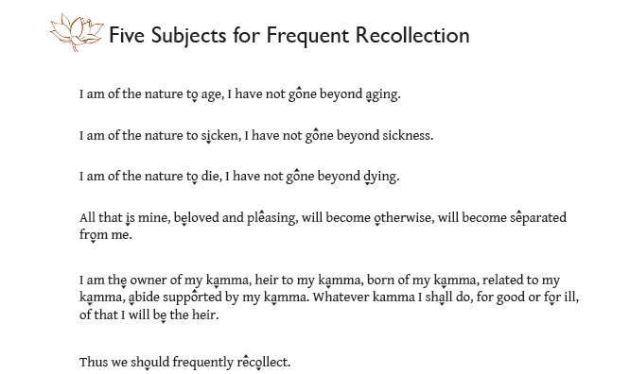
- Continue chanting the “Five Subjects for Frequent Recollection” daily
- Meditation:
  - Letting go of capabilities, letting go of roles, letting go of independence – Settle yourself in meditation, then bring up a reflection of how you would feel if you lost the ability to fulfill a role you now have or the ability to do something you currently are able to do or need help with a simple, necessary task. Where are your attachments to these things?
- Required Readings:
    - Doctor’s Guide to Aging - www.karunabv.org/homework-and-resources.html
- Suggested Readings
    - “The Simile of the Mountain” – Samyutta Nikāya 3.25 - www.accesstoinsight.org/tipitaka/sn/sn03/sn03.025.than.html
- Bring images or objects of encouragement in illness next week for the shrine

