Receiving the Heavenly Messengers -- Week 1 Homework
  - Observe elders (Who is old and who is an elder? Whom do you identify with? Who will YOU be when you’re old? What separates being an elder vs. being elderly?)
  - Reflect (and write):
    - What do I fear most about aging?
    - What do I look forward to or cherish about aging?
  - Chant the “Five Subjects for Frequent Recollection” daily
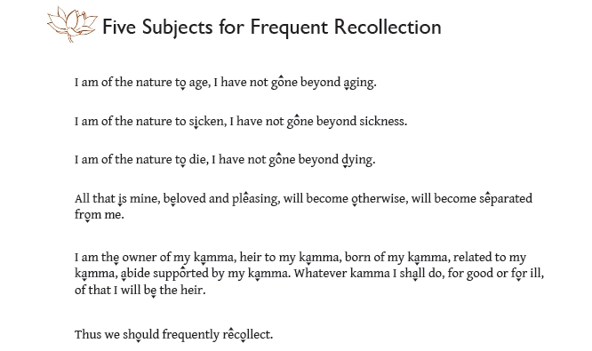

  - Meditation:
Bring up images of yourself in all the stages of your own aging – birth to death. How will you be in 5 years, 10 years, 20 years? How old will you be when you die?
  - Bring images or objects of aging next week for the shrine
  - Required reading: “Preparing for death and helping the dying” by Ven Sangye Khadro (you can find the readings at www.karunabv.org/homework-and-resources.html)
  - Suggested Reading: “Meeting the Divine Messengers” by Ven Bhikkhu Bodhi also at www.karunabv.org/homework-and-resources.html

